A Project Report On

“JALADURG”

Submitted To

MES Garware College of Commerce, Autonomous
And
Savitribai Phule Pune University

In partial fulfillment of the degree of

Bachelor of Business Administration- Computer Application



By

OMKAR A. SHELAR
Seat No: 14411
BBA-CA
Semester- (Semester IV)
Under the guidance of
MRS. PADMA NENE
Project Guide
MES Garware College of Commerce Autonomous, Karve Road, Pune 411004.
(2024-25)


MES GARWARE COLLEGE OF COMMERCE, AUTONOMOUS, PUNE-411004.
BACHELOR OF BUSINESS ADMINISTRATION - COMPUTER APPLICATION CERTIFICATE
This is to certify that Omkar A. Shelar Roll Number 14411 Exam Seat Number 4450512 Student of SY BBA-CA Semester-IV has successfully completed the project work in specialization subject Project based on HTML, CSS entitled as "JALADURG" partial fulfillment of the degree of Bachelors of Business Administration in Computer Application as per the syllabus of Garware College of Commerce, Autonomous and Savitribai Phule Pune University for the Year 2023-2024.

I further clarify that the work has been carried out under my supervision.

Project Guide BBA-Coordinator Principal

Internal Examiner External Examiner

Index

Sr. No. | Title | Page No.
1. | Introduction | 4
2. | Acknowledgement | 5
3. | Objectives | 6
4. | Scope of the Project | 7
5. | Hardware and Software Requirements | 9
6. | System Design | 10
7. | Layout of the Website | 13
8. | Limitations of System | 19
9. | Societal Survey | 21
10. | Conclusion | 23
11. | Bibliography | 24

1. INTRODUCTION

Maharashtra, located along the western coast of India, is renowned for its historical sea forts, which stand as timeless symbols of Maratha valor and architectural brilliance. These forts, built strategically along the Arabian Sea, played a crucial role in maritime defense during ancient and medieval times. They were instrumental in safeguarding the region from foreign invasions and controlling trade routes. Iconic sea forts like Sindhudurg, Vijaydurg, Suvarnadurg, Kolaba, Murud-Janjira and Madh Fort reflect the legacy of visionary leaders like Chhatrapati Shivaji Maharaj, who emphasized naval strength to protect his kingdom.

Each fort has a unique history and architectural style. For instance, Sindhudurg Fort, located on an islet in the Arabian Sea, is known for its massive walls and secret passages. On the other hand, Murud-Janjira, an unconquered sea fort, is renowned for its robust construction and complex defense mechanisms. These forts reflect a blend of military brilliance, traditional Indian architecture, and environmental adaptability.

This project aims to explore the historical significance, architectural uniqueness, and cultural importance of JALADURG. It also highlights the need for preservation and suggests ways to promote these forts as heritage tourism destinations.

2. ACKNOWLEDGEMENT

We express our sincere regard and indebtedness to our project guide, Mrs. Padma Nene, for her expertise, encouragement, and insightful feedback that have played a pivotal role in shaping the outcome of this project. This project gave us the opportunity to work on enhancing our technical skills.

Your mentorship has not only equipped me with practical skills but has also inspired us to have a sense of confidence and professionalism. This project helped us gain knowledge about diverse cultures and information about the wonders of the world. This project helped us understand the functionalities of the development of a static front-end web application.
We would like to thank all the faculty members of department for their constant support and encouragement.

3. OBJECTIVES

The primary objectives of this project on JALADURG are:
- To study the historical significance of the sea forts:
Understand the role these forts played in the defense strategies of the Maratha Empire, particularly under the leadership of Chhatrapati Shivaji Maharaj.

- To explore the architectural and strategic importance of these forts:
Examine the construction techniques, design principles, and strategic locations of the forts along the Maharashtra coastline.

- To highlight the role of the sea forts in Maratha naval history:
Investigate how these forts contributed to the growth and success of the Maratha Navy and their influence on maritime trade.

- To explore the preservation efforts and current status of the sea forts:
Assess the condition of these forts today, the challenges they face due to natural erosion and human impact, and the measures taken for their conservation and promotion as cultural heritage sites.

- To promote awareness about these forts among the public and future generations:
Increase the visibility and understanding of the historical and cultural importance of these sea forts through educational initiatives, tourism, and digital media.

4. SCOPE

The scope of this project is to comprehensively study and document the historical, architectural, and cultural significance of the sea forts along the coastline of Maharashtra. The project aims to:
- Study the prominent JALADURG:
Focus on major forts such as Sindhudurg, Vijaydurg, Murud-Janjira, Kolaba, and Suvarnadurg, along with other lesser-known forts that played a role in Maratha maritime history.

- Explore their architectural styles and construction techniques:
Examine the design, materials used, and unique architectural features of the sea forts, highlighting their strategic locations and the challenges faced in construction due to the coastal environment.

- Analyze their historical importance:
Investigate the role these forts played in defense, trade, and the preservation of the Maratha Empire’s naval power. The project will also consider the forts' strategic significance during battles and their influence on local and national history.

- Assess the current status and preservation efforts:
Evaluate the condition of these forts today, including factors such as weathering, human impact, and the efforts made by local authorities, heritage organizations, and the government to preserve and protect them.

- Discuss the tourism potential and challenges:
Explore how these forts can be developed as tourist attractions while maintaining historical integrity. Discuss the potential benefits of fort tourism for local economies and cultural preservation, along with the challenges of maintaining sustainable tourism.

- Promote public awareness:
Raise awareness about the cultural significance of these sea forts among the public, with the aim of fostering respect for heritage preservation and contributing to broader cultural education.

5. HARDWARE & SOFTWARE REQUIREMENTS

Hardware Requirements: -
• 1. Processor – Intel 3
• 2. Memory- 1 gb
• 3. Additional Devices- USB Drive and Printer

Software Requirements: -
• 1. Operating System - Windows 7
• 2. Front End - HTML, CSS
• 3. Browser: Google Chrome

6. SYSTEM DESIGN

Entities of ERD

  - Fort
  - Ruler
  - Event
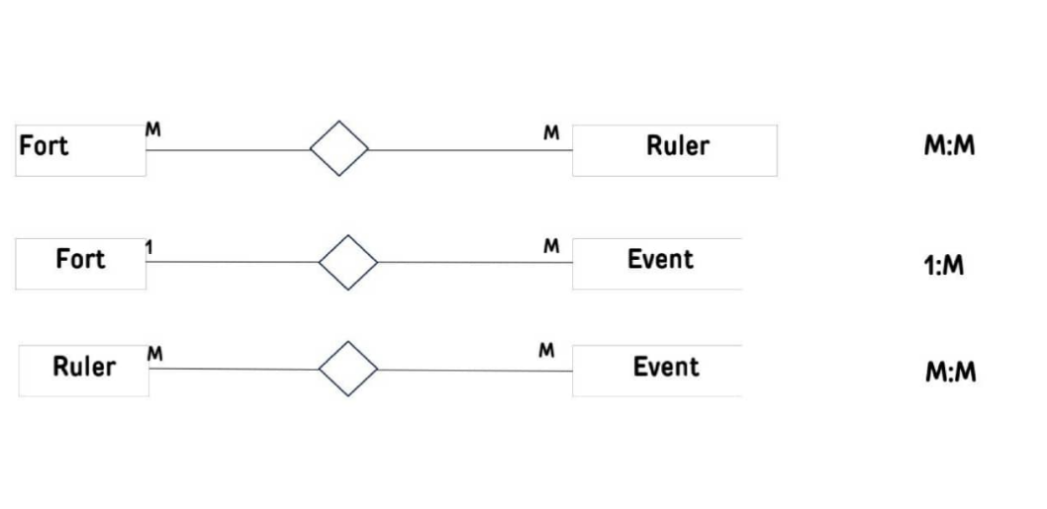
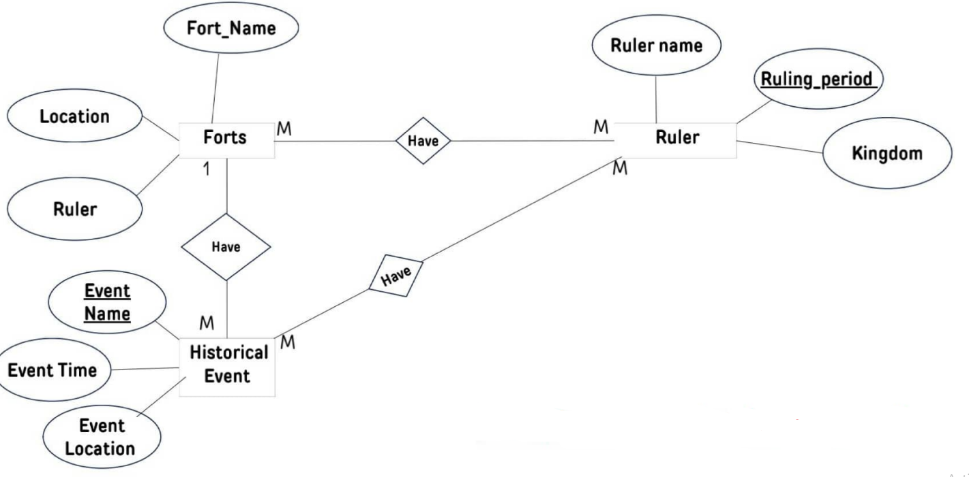
Context Level DFD

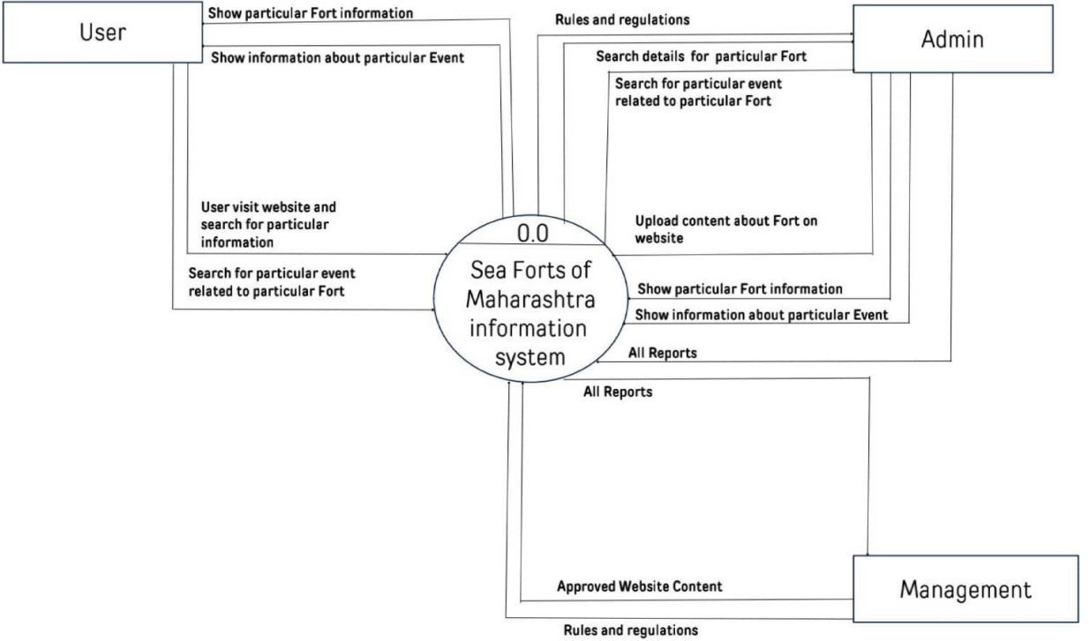

First Level DFD

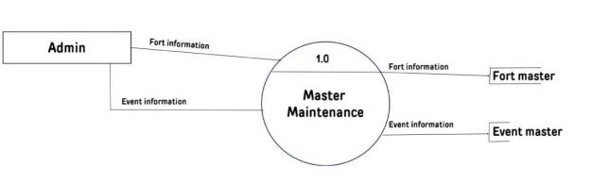

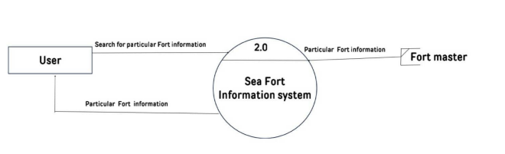

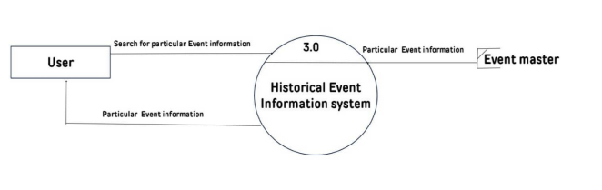

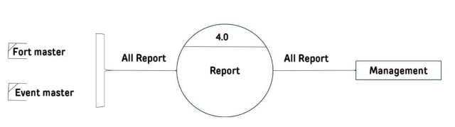

- LAYOUT OF THE WEDSITE

Home Page
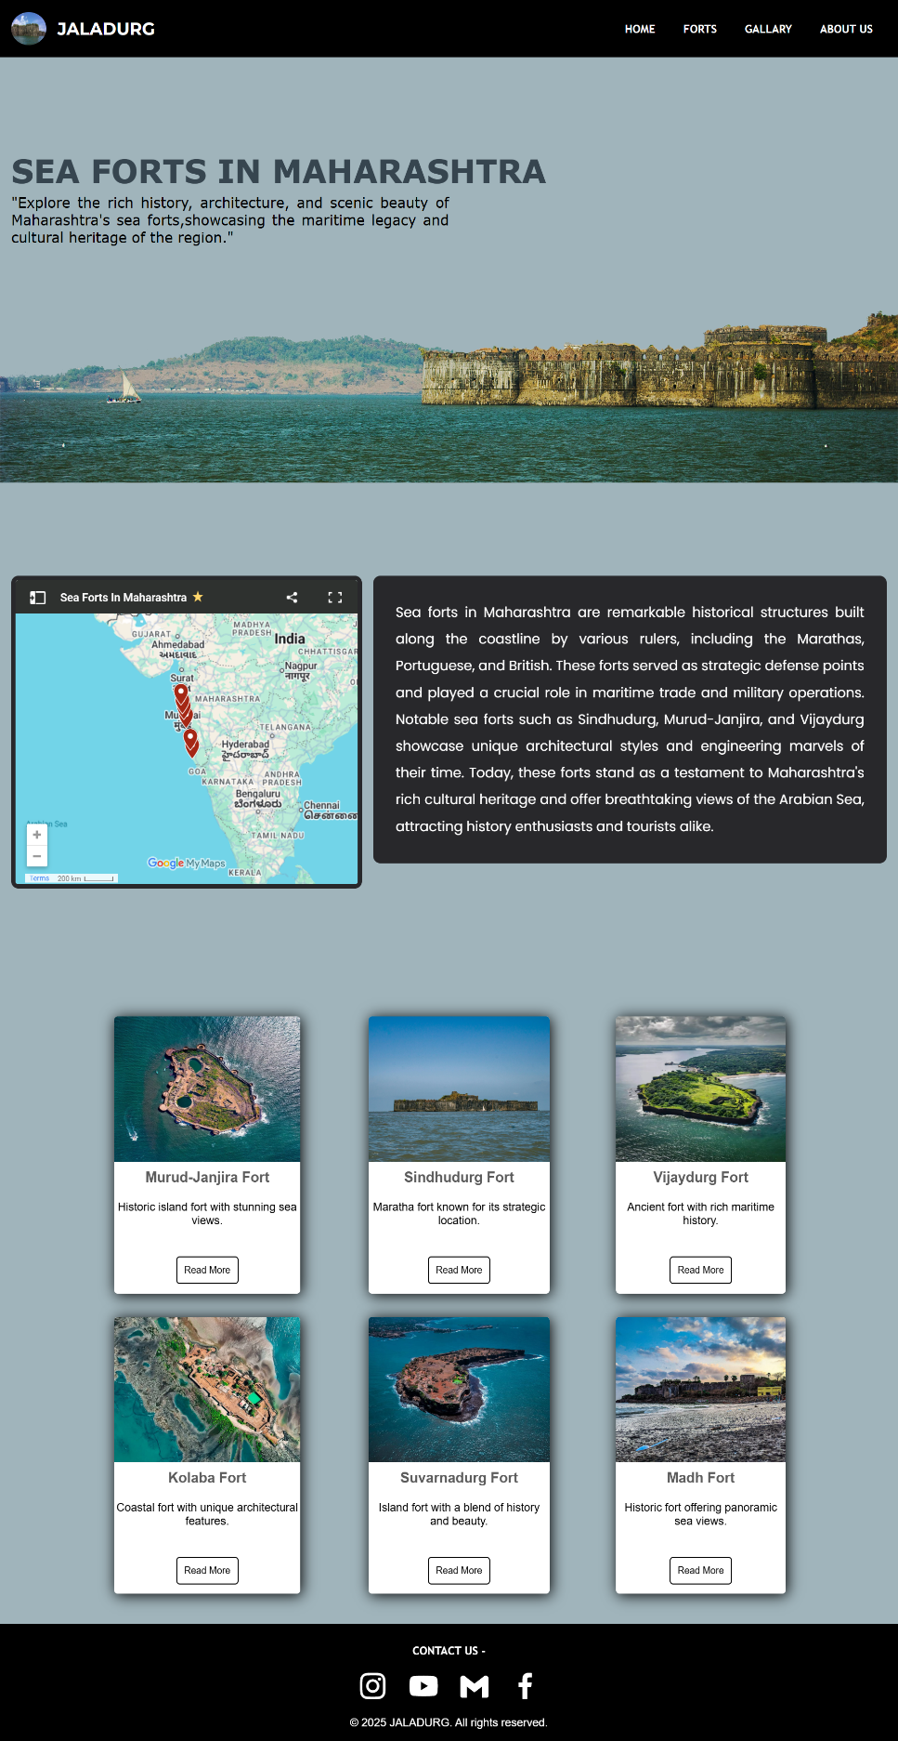

Forts >> Murdu-Janjira Fort
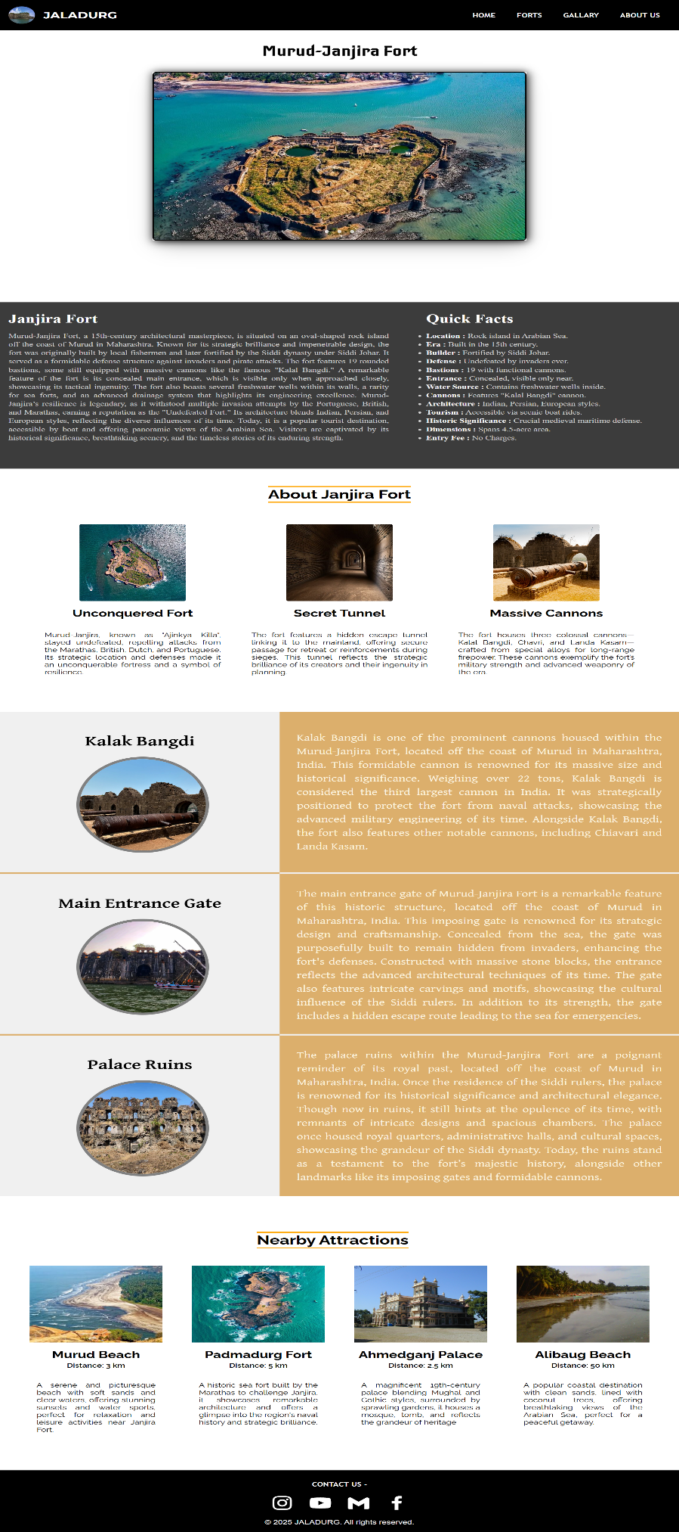
Forts >> Sindhudurg Fort
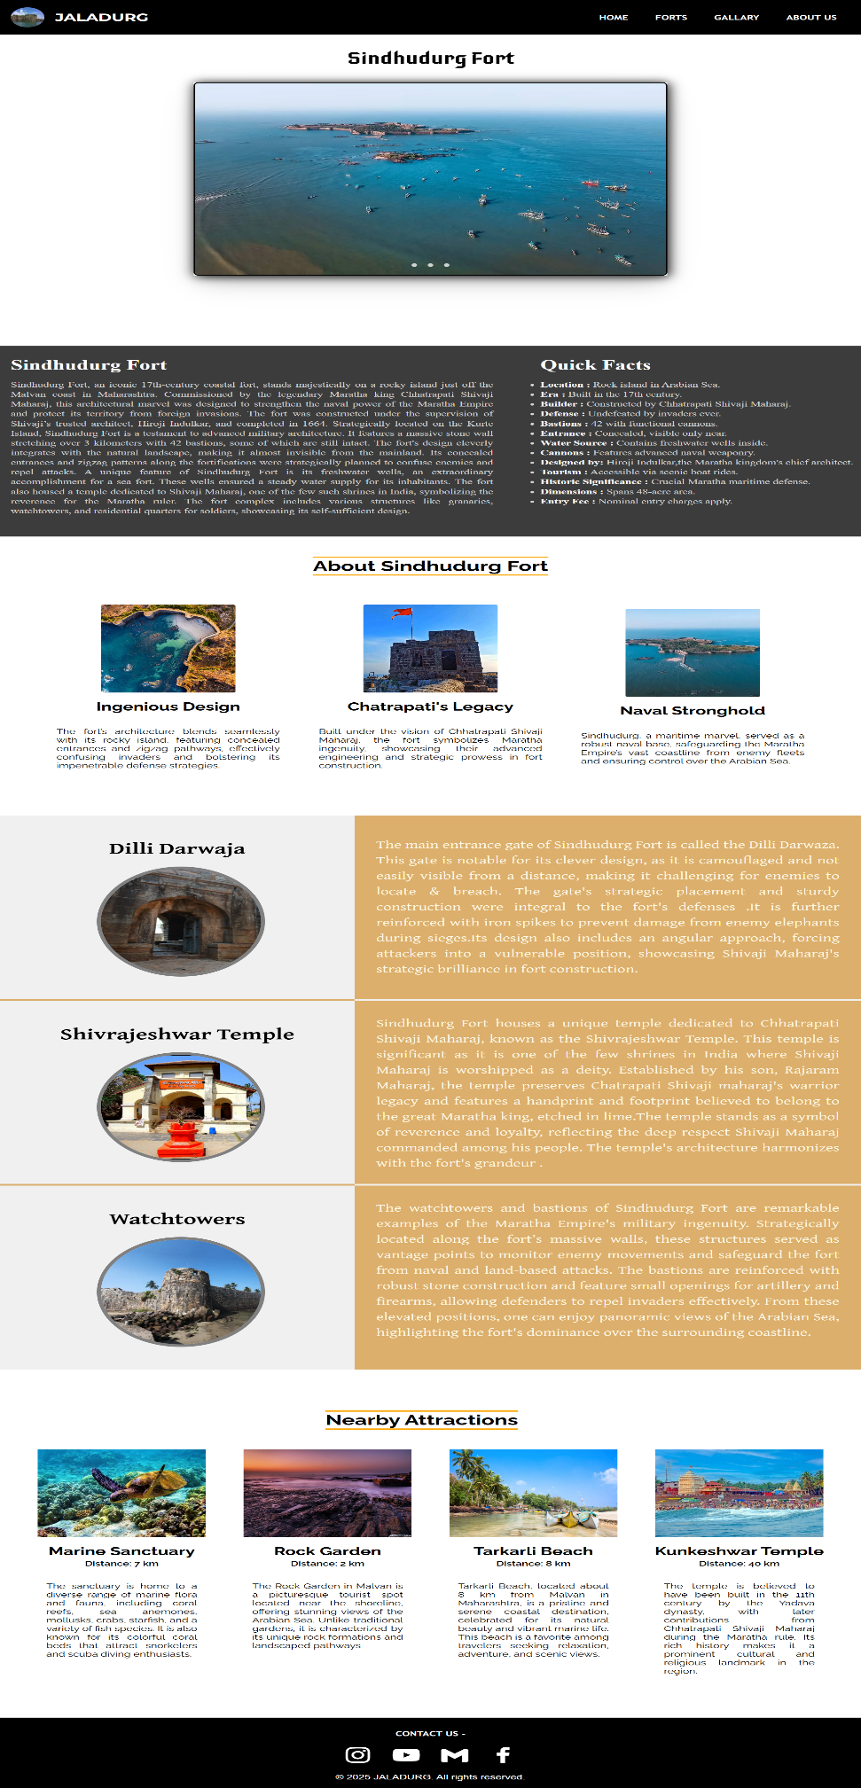
Forts >> Kolaba Fort
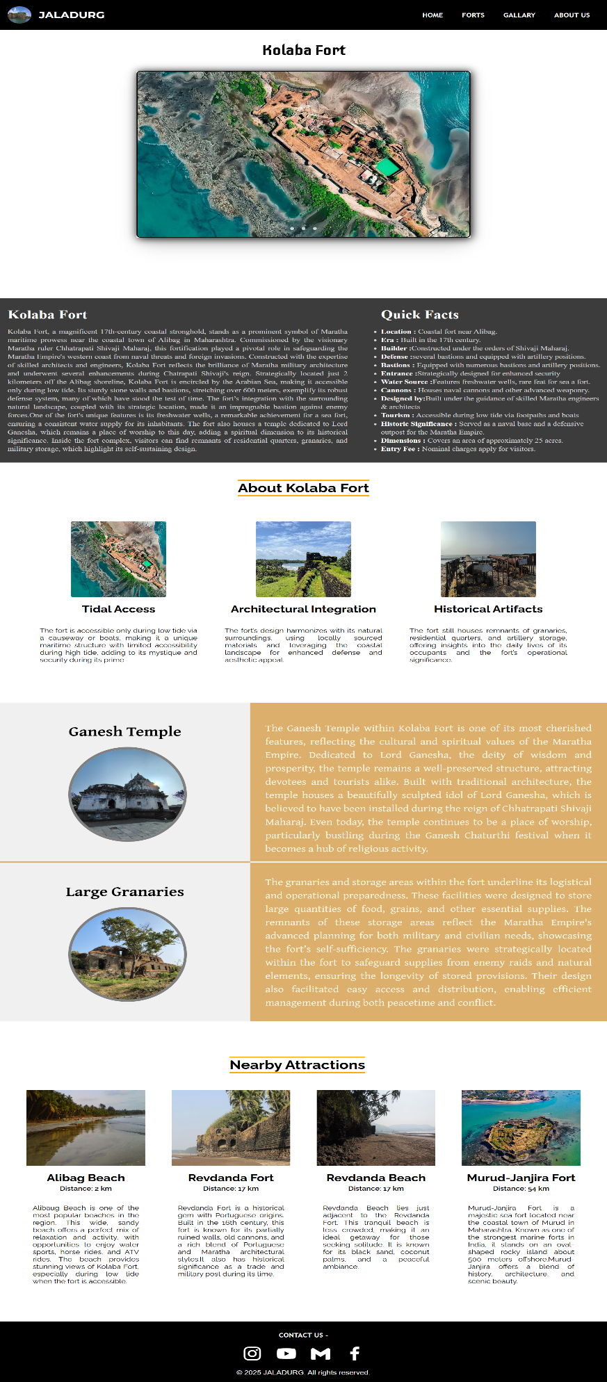

Gallary page

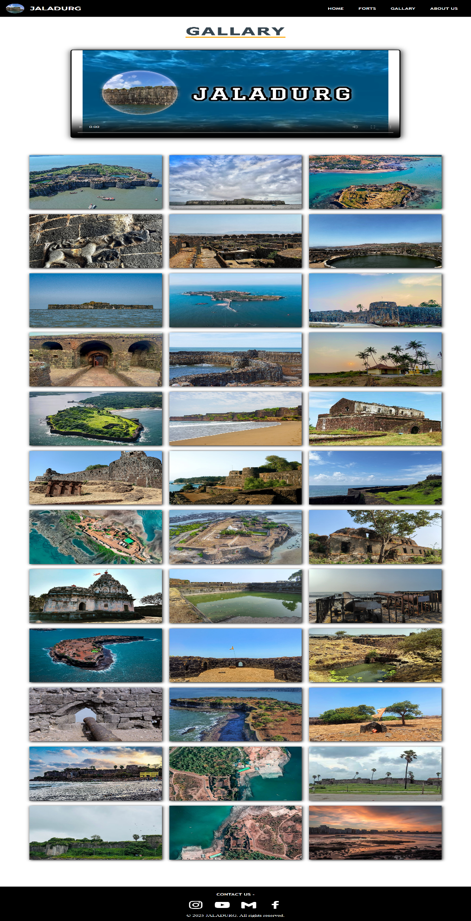

About Us page

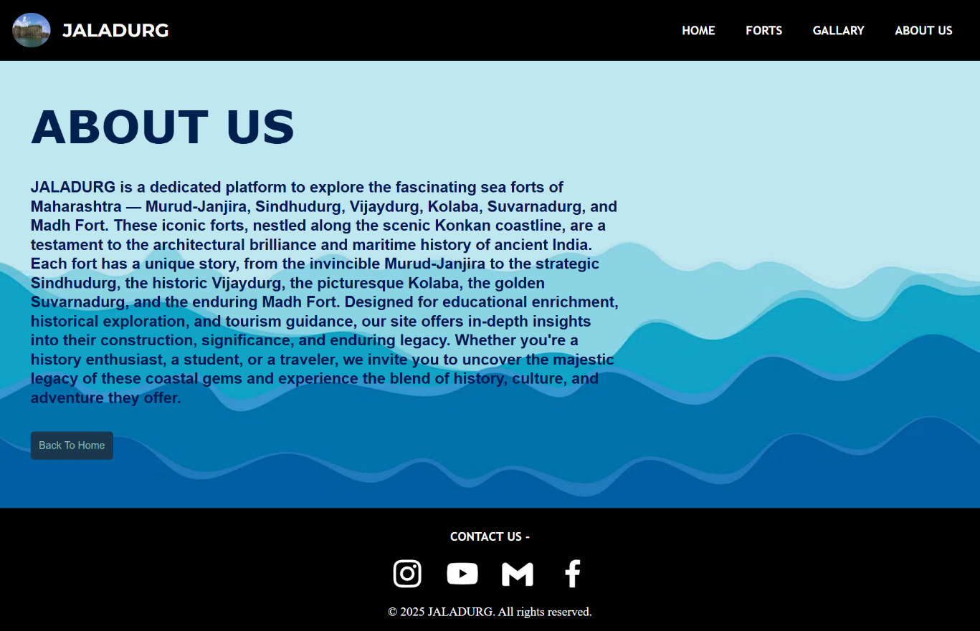
8. LIMITATION OF THE WEBSITE

While the website aims to provide a comprehensive and user-friendly experience for visitors interested in JALADURG, there are certain limitations that need to be considered:
- Limited Coverage of Forts:
Due to time and resource constraints, the website may not cover every single JALADURG. While it will include major forts like Sindhudurg, Murud-Janjira, and Kolaba, some smaller or less accessible forts may not be included in the initial release.

- Lack of Physical Access:
Since the website relies on available research and digital media, it cannot offer physical experiences or live visits to the forts, which may limit the richness of the experience for users who prefer direct interaction with these historic sites.

- Static Information:
The website may primarily feature static information, such as text and images. Dynamic elements such as real-time updates or interactive features (e.g., live tours or augmented reality) may not be fully implemented due to technological or budget limitations.

- Incomplete Historical Data:
Some forts may have limited documented history or resources available for research. As a result, certain historical data may be unavailable, and the information provided may be incomplete or based on secondary sources.

- Accessibility and Compatibility Issues:
While the website aims to be accessible to a wide audience, compatibility issues may arise with certain devices or older browsers, limiting the user experience for some visitors. Ensuring full accessibility across all platforms may require ongoing updates.

- Internet Connectivity:
Since the website is an online platform, users with slow or limited internet connections may experience delays in loading multimedia content such as images, videos, or interactive maps, which may hinder the overall user experience.

- Maintenance and Updates:
Continuous updates and maintenance are necessary to keep the website current. However, there may be periods when the site is temporarily unavailable for updates or improvements.

9. SOCIETAL SURVEY

Report

This is the report of social survey taken on our website
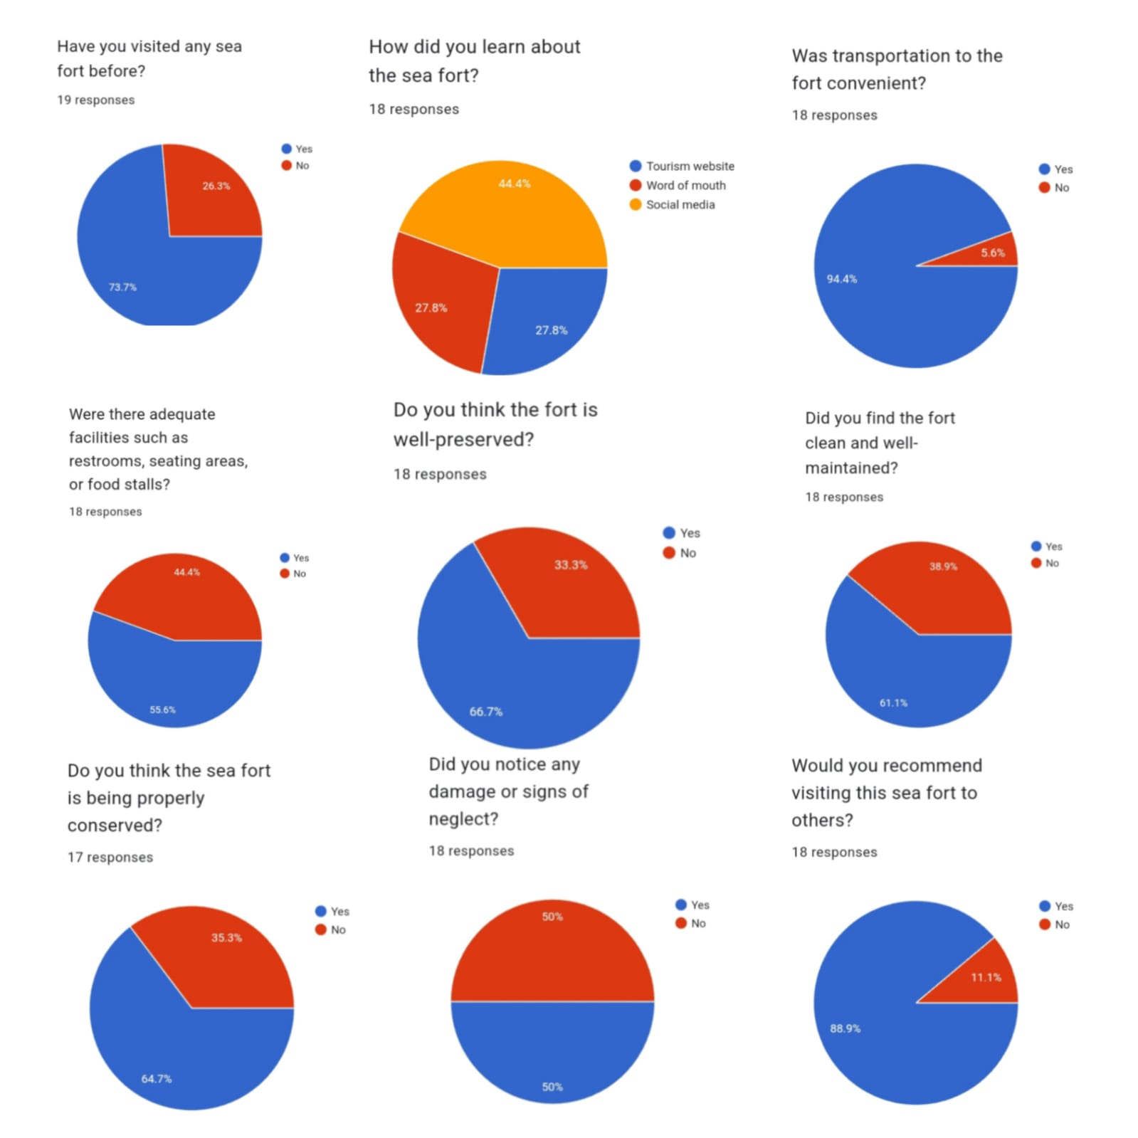
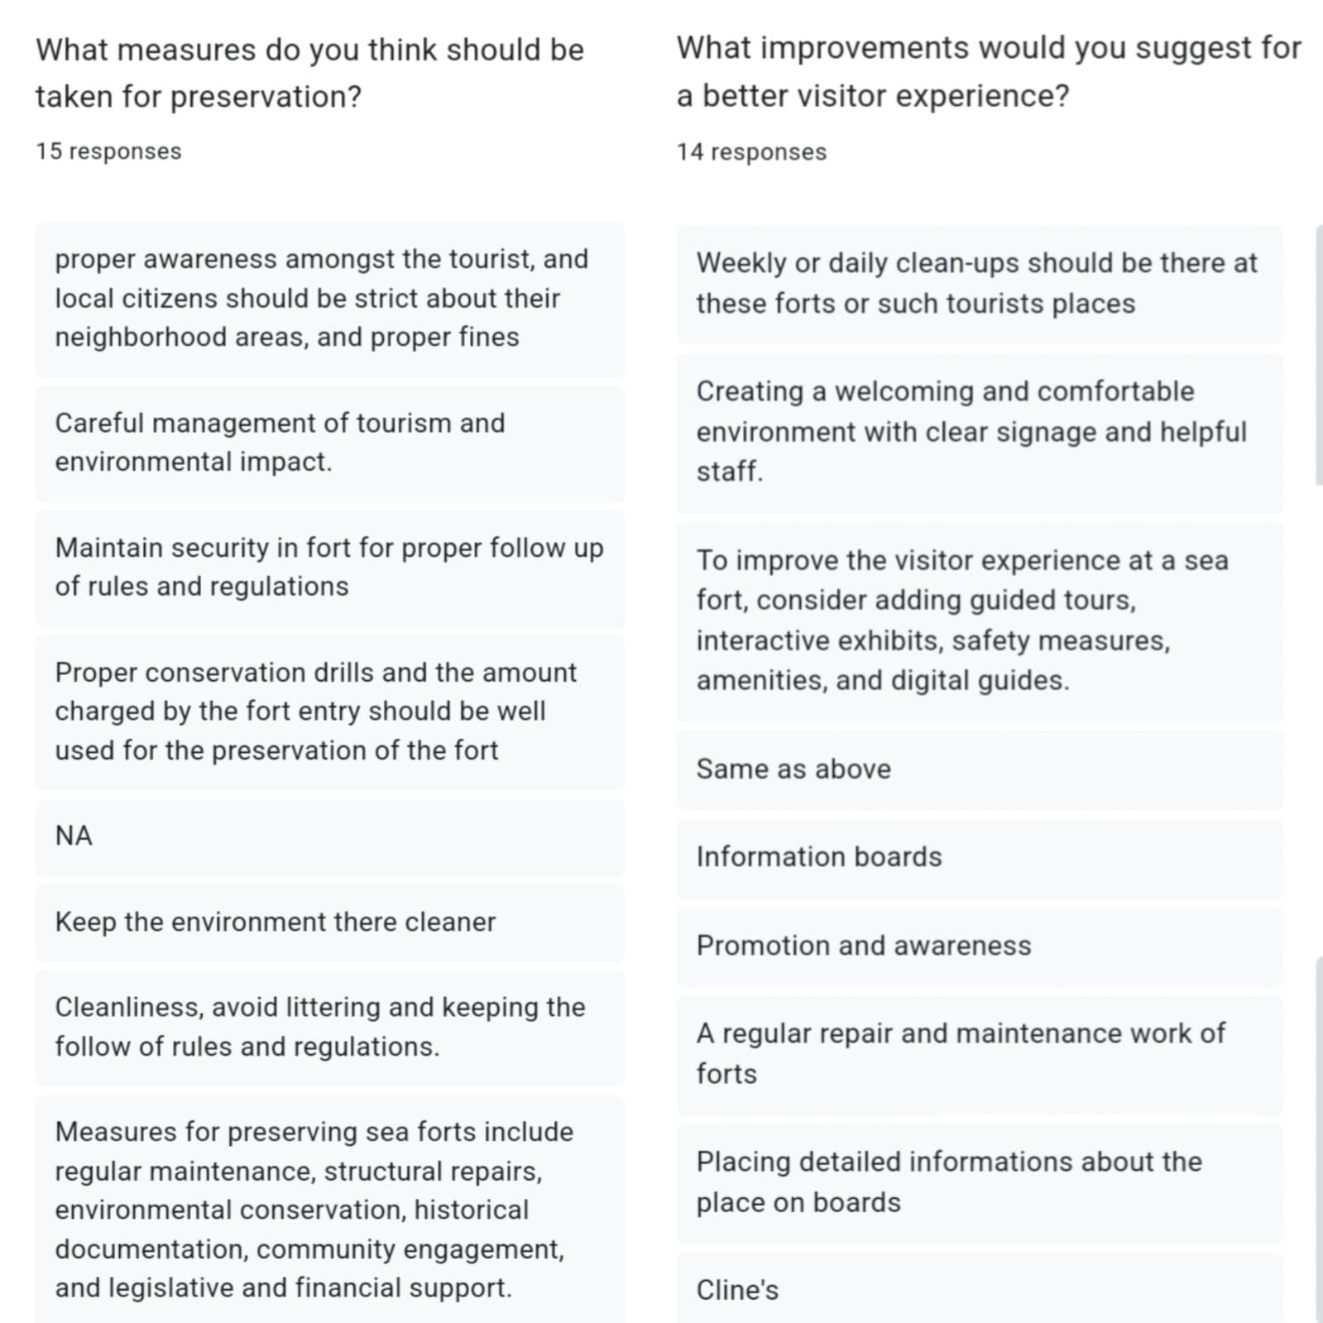
10. CONCLUSION

JALADURG are not just architectural marvels; they are a testament to the strategic brilliance and maritime prowess of the Maratha Empire. These forts, strategically positioned along the coastline, played a critical role in defending the region from foreign invasions, safeguarding trade routes, and strengthening the naval power of the Marathas. Each fort, from Sindhudurg to Murud-Janjira, carries with it a unique historical narrative that reflects the courage and vision of the leaders who built them, particularly Chhatrapati Shivaji Maharaj.
The exploration of these forts not only highlights the military and architectural genius of the time but also offers valuable insights into the culture and heritage of Maharashtra. These forts stand as monuments of pride for the people of Maharashtra and India, providing a rich link to the past while contributing to the cultural landscape of the state.
The societal survey revealed that the public is increasingly aware of these forts, with growing interest in preserving and visiting them. However, challenges such as lack of infrastructure, limited accessibility, and conservation issues remain. There is a clear need for coordinated efforts between local authorities, historians, conservationists, and tourism organizations to ensure that these forts are preserved for future generations and promoted responsibly as cultural and historical destinations.
The ongoing efforts to conserve and develop these forts into tourist-friendly sites should strike a balance between promoting tourism and protecting the historical integrity of the forts. By raising public awareness and engaging local communities in heritage preservation, JALADURG can continue to inspire pride and interest in the region’s rich history.
In conclusion, the sea forts of Maharashtra are more than just ruins; they are symbols of the state’s rich naval heritage and an integral part of India’s history. Their preservation and promotion are essential not only for cultural education but also for ensuring that future generations can learn from and appreciate these monumental treasures.

11. BIBLIOGRAPHY

The following sources were referenced during the research and preparation of this project on the JALADURG:
- Books:
  - Desai, Ramesh. JALADURG. Pune: Sagar Publications, 2010.
  - Datar, Yashwant. The Legacy of Shivaji Maharaj: Maritime History of Maharashtra. Mumbai: Maratha History Trust, 2015.
  - Joshi, Suresh. Forts of Maharashtra: A Historical Journey. New Delhi: Indian History Press, 2008.

- Websites:
  - Thrillophilia "Maharashtra Sea Forts."
  - https://www.thrillophilia.com/sea-forts-in-maharashtra
  - Archaeological Survey of India (ASI). "Preservation and Protection of Maharashtra's Forts." www.asisearch.in.

- Journals & Articles:
  - Patil, Prakash. "Naval Forts of the Maratha Empire: The Strategic Importance." Journal of Maratha History, Vol. 42, No. 3, 2017, pp. 89-105.
  - Mehta, Kiran. "Forts of Maharashtra: Cultural Monuments of the Coastal Region." Heritage Studies Review, Vol. 15, No. 1, 2019, pp. 58-74.

- Reports:
  - Conservation and Preservation of Maharashtra’s Coastal Forts: A Government Initiative. Government of Maharashtra, 2020.
  - Tourism and Heritage Preservation in Maharashtra. Maharashtra Tourism Department, 2021.

